**Project Documentation - Movie Management System**

**Introduction**

This project is a Movie Management System built entirely with JavaScript, Express, and MongoDB. The application allows users to manage a list of movies including adding new movies, editing existing ones, deleting movies, and viewing all stored movies.

**Technologies Used**

- JavaScript

- Express.js

- MongoDB

- Mongoose

- HTML

- CSS

- Bootstrap

**Features**

- Add a new movie to the database.

- Edit/delete details of existing movies:

Only the user who created a movie is allowed to edit or delete it. This ensures that exclusively its original creator, preventing other users from making unauthorized changes, manages each movie entry.

- Display a list of all movies.

- Daily action limit for each user is 10 actions.

If a user exceeds their daily action limit, they should be notified and proactively disconnected from the system until the next day when a new set of 10 actions is granted.

If a user does not use their full daily action allowance, the remaining unused actions from the previous day will be added to their updated action count after the next day.

**Database Structure**

MongoDB is used as the database. The movies are stored in a collection named 'movies'. Each movie schema (model) includes the following fields:

- name: String

- director: String

- releaseDate: String

- length: Number

- picture: String

- userId: String (taken from the mongoDB)

**Endpoints**

The following endpoints are available in the system:

1. GET /movies - Retrieve all movies

2. POST /movies - Add a new movie

3. GET /movies/:id - Retrieve an existing movie by ID

4. PUT /movies/:id - Update an existing movie by ID

5. DELETE /movies/:id - Delete a movie by ID

**Conclusion**

The Movie Management System is a simple effective project demonstrating the integration of JavaScript, Express, and MongoDB to build a CRUD-based web application. Users can efficiently manage movies through the intuitive endpoints provided.

**Screenshots**

Login Page:

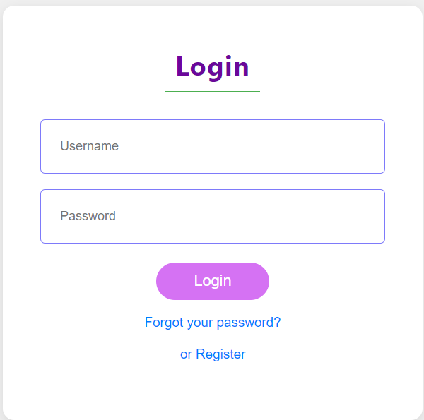

Forgot your password:

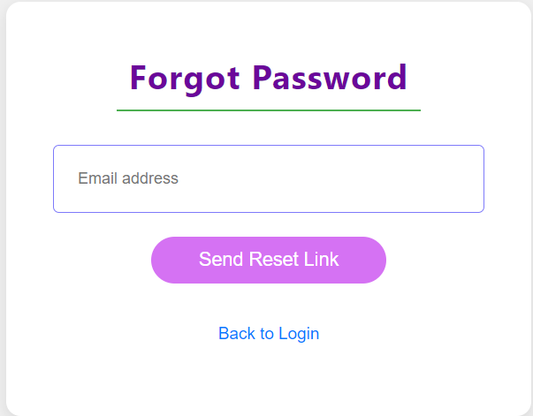

Reset Password:

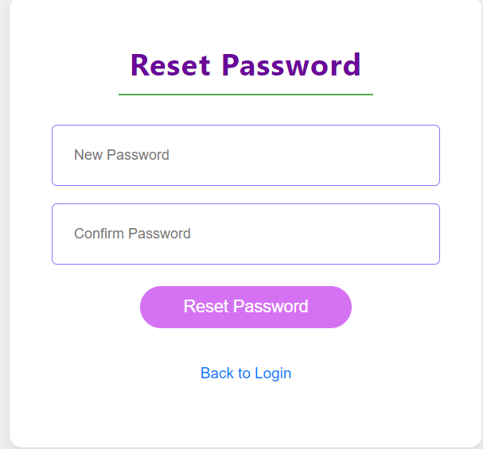

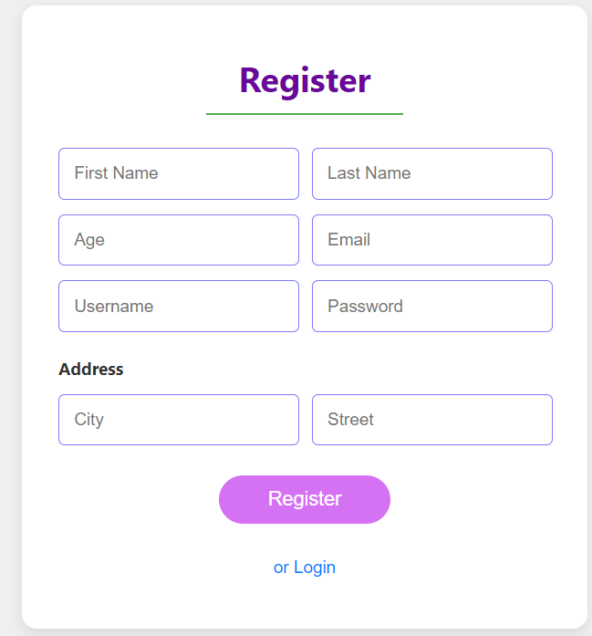Register Page:

Home Page:

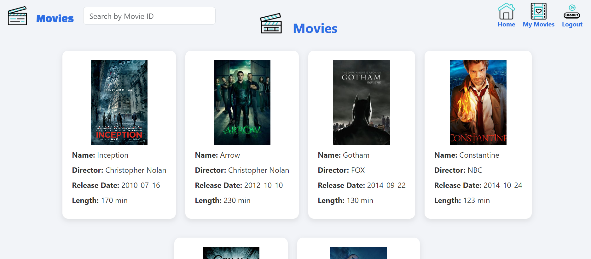

My Movies:

